FOCUS GROUP REPORT

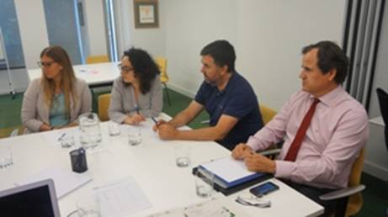
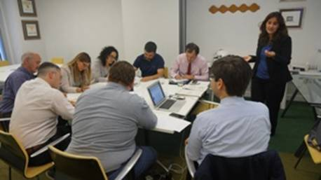

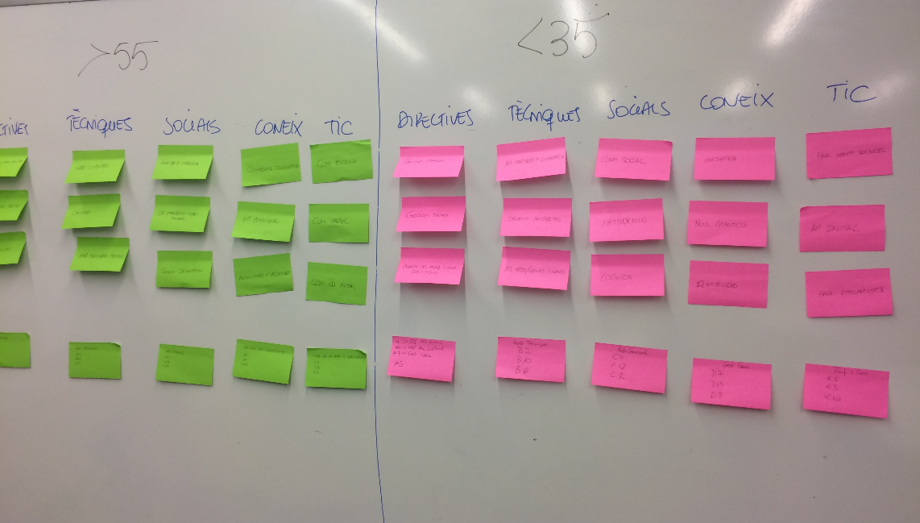

1. INTRODUCTION

In the framework of the ILPO55 project, a focus group was organised on the 28th May 2015 from 6 to 8pm at IEF. The focus group, moderated by Alicia Berlanga, counted on the participation of 7 people from different financial services activities accurately selected to contribute to the results of the survey and propose their contributions.

2. FOCUS GROUP PARTICIPANTS

STAKEHOLDERS | NAME AND SURNAME OF PARTICIPANTS | COMPANY  INSTITUTION | COUNTRY | EMAIL
>55 | Francesc Suriol | La Caixa | Spain | fsuriol@lacaixa.es
<35 | Natàlia Ribé | Solventis A.V. | Spain | nataliaribea@gmail.com
35-55 | Pedro Aparicio | Aturat | Spain | peapca@gmail.com
Human resources directors  Banking sector | Salvador Farres  Maria José Martínez | Banc Sabadell  CatalunyaCaixa-BBVA | Spain  Spain | Farres@sabadellatlantico.com  maria-jose.martinez@catalunyacaixa.com
Professional Association | Victor Garcia- Vivancos | Ex member of ADICAE | Spain | vgvivancos@hotmail.com
Other (workers union association?) | Miquel Angel Esteban | secpb | Spain | maesteban@secpb.com

5

4. FOCUS GROUP SITUATION

Structure of the Focus Group
The Focus Group consisted of two parts: an introduction and the group discussion.

Introductory Part

- Welcome of participants
- Self-introduction of the moderator and their institution
- Introduction to the ILPO55 project and the aims of the Focus Group
- Information about data protection and asking permission of keeping records/photographs
- Self-introduction of the focus group participants:
  - Profession
  - Institution
  - Expectations on participation in focus group

Focus Group Objectives and key issues:

- Alicia Berlanga did a presentation on the results of the questionnaire, “competencies” part in order to check, verify the results of the main competencies outlined by the survey:
  - MANAGEMENT SKILLS
  - TECHNICAL SKILLS
  - SOCIAL SKILLS
  - PERSONAL SKILLS
  - INFORMATION AND COMMUNICATION TECHNOLOGIES SKILLS

Due to the big overview that the questionnaire offers, the focus group took most of the time for the prioritisation of the main competencies over 55 and under 35 can offer. This information is of extreme relevance for, on one hand, identify the main topics to be covered under “intergenerational activities”, and on the other, support the new qualifications for over 55 that ILPO55 will further develop.

The main findings on the competencies agreed by all the focus groups participants have been:
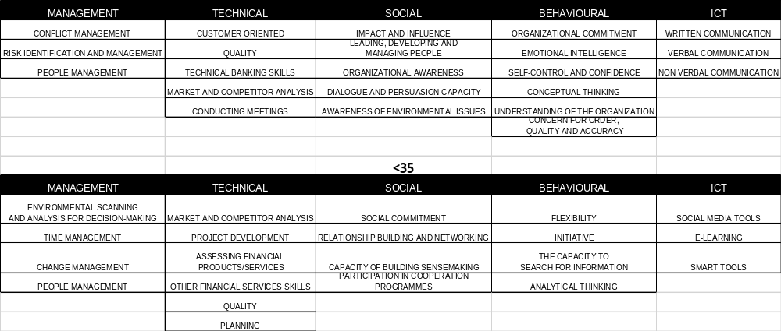
This information can be relevant for the definition of the main areas where an intergenerational cooperation could take place using training, coaching or other activities to exchange strengths and improvement weaknesses.
- Identification of interesting practices regarding age management and intergenerational activities in your country

Name of the practice | Company  Institution | Type of practice (training, mentoring, online activities, social activities, cooperation, job shadowing, other.) | Transferability | Sustainability
Solidarity between generation of workers  http://www.fesugt.es/noticias/20120223-desarrollo-de-la-solidaridad-entre-las-generaciones-de-trabajadores/ | European Project | Training | Yes | Yes
Age management | Banc Sabadell | Internal training/  mentoring | --- | ---

Related information:

- Un oficio que ya no es de por vida http://economia.elpais.com/economia/2015/03/27/actualidad/1427480008_605333.html
- Nueva vida después de la banca http://www.factorhuma.org/index.php?option=com_content&view=article&id=9276%3Anueva-vida-despues-de-la-banca-&Itemid=33&lang=ca
- Libro verde sobre la Responsabilidad Social Corporativa en el sector financiero: Una aproximación a la sostenibilidad de las entidades financieras http://www.ceca.es/wp-content/uploads/2015/01/libro_verde_responsabilidad_social_corporativa.pdf

6. CONCLUSIONS

- The group considers that the intergenerational activities are extremely relevant and could be a useful way to exchange competencies that over 55 have acquired through working experience and, on the other, under 35 have recently learnt from their educational experience.
- Technological abilities are considered as an opportunity to be acquired by over 55 for different purposes: online teaching or mentoring, for instance.
- There are no relevant good practices to be shared as most of them declare that intergenerational activities have not really been implemented in their companies. Some state that over 55 are usually involved in activities such as initial training to new employees but it is not a process that is afterwards sustained during a longer period.
- The group will act during the lifetime of the project as a “consulting body” so that, as stakeholders, can follow-up the activities and provide guidance on the usefulness of the outcomes produced.

